
PROJECT REPORT OF
Github Link : http://github.com/Sumiaya256/Poth-Chola-A-Travel-Agency

- Introduction:

  - Purpose
The purpose of the Travel Agency System is to provide travelers with a simple, reliable, and user-friendly platform where they can browse, compare, and book travel packages with ease. By offering three distinct package tiers-Basic, Standard, and Premium-the system ensures that users can select an option that best matches their budget and preferences. The platform reduces the stress of travel planning by streamlining the entire process, from package exploration to secure booking and final confirmation. It also allows travelers to make confident decisions by presenting verified reviews from past users. Beyond serving travelers, the system supports hotels, transport providers, and other partners by generating more bookings and strengthening business collaborations. Overall, the Travel Agency System is designed to make travel planning more convenient, trustworthy, and efficient for users while also creating value and growth opportunities for service providers.

  - Intended Audience
The intended audience of the Travel Agency System includes a wide range of users and stakeholders who will directly or indirectly benefit from the platform. Primarily, it is designed for travelers-from students and solo explorers to families and frequent vacationers-who seek an easy and trustworthy way to plan and book their trips.

  - Scope

The platform allows:
Users to register, browse, compare, and book three types of travel packages-Basic, Standard, and Premium. It enables secure bookings, displays verified traveler reviews, and generates confirmation details.
The system also connects with hotels and transport providers for smooth travel arrangements and supports customer service teams in managing bookings.
The Admin manages users, packages, bookings, reviews, and partner data to ensure the Travel Agency System runs smoothly and remains reliable.

2.Overall Description
2.1 Product Perspective
The perspective of the Travel Agency System is to build a web-based platform that enables travelers to easily browse, compare, and book tiered travel packages, while providing admins and service providers with tools to manage bookings, packages, and user interactions efficiently.

2.2 Product Functions

- User Registration / Sign In / Sign Up
- Browse & Compare Packages
- Booking & Reservation
- Payment Processing & Confirmation
- Verified Reviews
- Admin Functions
- Partner Integration

  - User Classes and characteristics:

- Traveler / User: Individuals planning trips; may be students, solo travelers, families, or frequent vacationers.
- Admin: System managers responsible for maintaining the platform.
- Customer Service Team: Supports assisting users with bookings and queries.
- Service Providers (Hotels, Transport, Activity Managers): External partners providing services included in travel packages.

3.Specific Requirements
3.1 Functional Requirements

3.1.1User Registration & Login
- The system shall allow users to create an account with a valid email and password.
- The system shall allow users to log in securely using their credentials.
- The system shall provide options for users to reset or recover passwords.
- The system shall store user information securely in the User Database.
3.1.2 Browse & Compare Packages
- The system shall allow users to view all available travel packages (Basic, Standard, Premium).
- The system shall display package details, pricing, and inclusions.
- The system shall allow users to compare multiple packages side by side.
- The system shall display verified traveler reviews for each package.
3.1.3 Booking & Reservation
- The system shall allow users to select a package and enter personal and travel details.
- The system shall allow users to submit bookings securely.
- The system shall validate all booking inputs before submission.
3.1.4 Payment Processing & Confirmation
- The system shall calculate the total cost of the selected package.
- The system shall provide a confirmation page summarizing booking details, package, travel dates, and total cost.
- The system shall store booking details in the Booking Database.
3.1.5 Admin Functions
- The system shall allow admins to manage users, packages, bookings, reviews, and partner information.
- The system shall provide access control to distinguish between admins and regular users.

3.2 Non-Functional Requirements
3.2.1 Performance
- The system shall load pages within 3 seconds under normal network conditions.
- The system shall handle at least 500 concurrent users without performance degradation.
3.2.2 Reliability & Availability
- The system shall be available 99% of the time, excluding scheduled maintenance.
- The system shall prevent data loss by maintaining regular backups of user and booking data.
3.2.3 Usability
- The system shall have a responsive design accessible on desktops, tablets, and smartphones.
- User instructions and error messages shall be clear and helpful.
3.2.4 Security
- The system shall encrypt all sensitive data including passwords and personal information.
- The system shall ensure secure login and access control for admin and user accounts.
- The system shall prevent unauthorized access to booking, payment, and admin data.
3.2.5 Maintainability
- The system shall be designed so that upgrades, bug fixes, and feature additions can be done with minimal disruption.
- The code shall be well-documented for future developers.
3.2.6 Compatibility
- The system shall support modern web browsers (Chrome, Firefox, Edge, Safari).
- The system shall be compatible with different screen sizes and devices.
3.2.7 Scalability
- The system shall allow for future expansion, such as adding more packages, destinations, or integrating with payment gateways and travel APIs.
3.2.8 Data Integrity
- The system shall ensure that all booking, user, and payment data are accurate and consistent across databases.
3.2.9 Response Time
- The system shall provide feedback to user actions within 2 seconds, such as confirming a booking or updating user details.
4. Primary Stakeholders:
• Travelers / Users
• Admin / System Managers
• Customer Service Team
• Hotels, Transport Providers, and Activity Managers
• Developers and Product Managers

Findings from interview:
Interviews (students of EWU):

Questions | Response | Insights / Notes
How do you usually plan and book your trips? | I browse multiple travel websites to compare packages, check reviews, then book through the most reliable site. | Users want a single, reliable platform to simplify comparison and booking.
Do you read traveler reviews before booking? | Yes, but only if they are genuine. | Verified reviews are important to build trust.
What payment methods do you prefer for booking trips? | Credit/debit cards, mobile payments, or trusted online wallets; security is important. | Secure payment integration is critical.
How long do you spend comparing travel packages before booking? | Usually several hours across multiple sites. | Indicates the need for a single platform with comparison features to save user time.
How much detail about costs do you expect before booking? | I want a full breakdown of costs, including accommodation, transport, activities, and taxes, so there are no surprises. | Users expect a transparent breakdown of all costs before confirming a booking
What challenges do you face while booking travel online? | Confusing package comparisons, unclear pricing, and worrying about fake reviews. | Highlight need for clear comparison, transparent pricing, and verified reviews.

5.Usage Scenario:
User’s Perspective
A user (traveler) opens a browser and navigates to the Travel Agency website. The homepage displays:
- Sign In / Sign Up – For account access
- FAQs – Answers common questions
- Reviews – Verified traveler experiences
- Packages – Travel packages available for booking
- About-Demonstrates the website
The traveler clicks Sign Up (if new) or Sign In (if already registered). For Sign Up, the traveler provides Name, Email, Password (must be 6 digits) and Phone number. Once signed in, the traveler is redirected to the homepage.
If the traveler is interested to get a tour, the traveler goes to Packages. The traveler clicks Packages from the menu. Packages are displayed with key details such as price, itinerary highlights, seat availability, inclusions, and duration. The traveler can filter packages by destination, transportation system, room types and rates.
The traveler can consult FAQs to resolve common queries about booking, cancellations, or payment options.
The traveler can click Reviews to read verified experiences from other travelers. Ratings and comments help in evaluating the quality of packages.
The traveler chooses a package that fits their needs. He clicks Book Now to proceed. By simply clicking the Book Now option a traveler enters the Number of Person, type of room he needs (Single room, Double Room, Family Room).
- Single Room- 1person/Room
- Double Room- 2 persons/Room
- Family Rooms – 3-4 persons/Room
Where, per person: Transport 700 Tk, Full board 1800 Tk, Per room: Accommodation (Single base) 1000 Tk.
After providing all the information the user clicks to Proceed to Payment. A booking summary appears with the provided Package, Location, Number of People, Rooms along with total payment. The user gets to choose a payment option (Bkash ,Nagad and Online Banking). After providing the valuable information to the system the user completes payment.
After payment, a confirmation page is displayed, saying, User completes the payment successfully. Displayed Information:
• Confirmation Message
- Booking Confirmed
- Example: "Your booking for Cox's Bazar (Basic) has been confirmed!"
• Booking Details
- Package
- Location
- People
- Rooms
• Payment Information
- Payment Method
- Transaction ID
- Date & Time
• Cost Breakdown
- Transport
- Full Board (Food)
- Accommodation
- Grand Total
• Action Buttons
- Print Memo – allows user to download/print the confirmation receipt.
- Back to Home – redirects the user to the homepage to browse more packages.
The user can drop a post-trip review if he wishes to. User needs to login first. Navigates to “My Profile” → “My Reviews” or clicks a prompt to leave a review. User enters:
- Rating (1–5 stars)
- Comments or feedback
User clicks Submit. System saves the review and displays it under “My Reviews” and on the public Reviews section for other users to see. The user can edit or delete its review as well.
Admin’s Perspective:
Admin (Admin (identified by admin@pothchola.local) can update package details, adjust pricing, apply promotional discounts, and manage availability based on partner input. They monitor system performance, handle booking reports, and manage customer inquiries and cancellations. The platform also facilitates direct coordination with external partners—confirming reservations, updating inventory, and generating partner reports—ensuring that services run seamlessly from the back end.
An account for the administrator will be given to the agency management with a predefined username and password. An administrator can login with the predefined username and password given by the system authorities.
Admin Dashboard Features
Inside admin page there are,
- Manage Packages: Add, edit, delete packages.
- Manage FAQs: Add, edit, delete FAQs.
- Manage Users: View all registered users.
- Manage Reviews: View, approve, or delete reviews.

6.Use Case Diagram
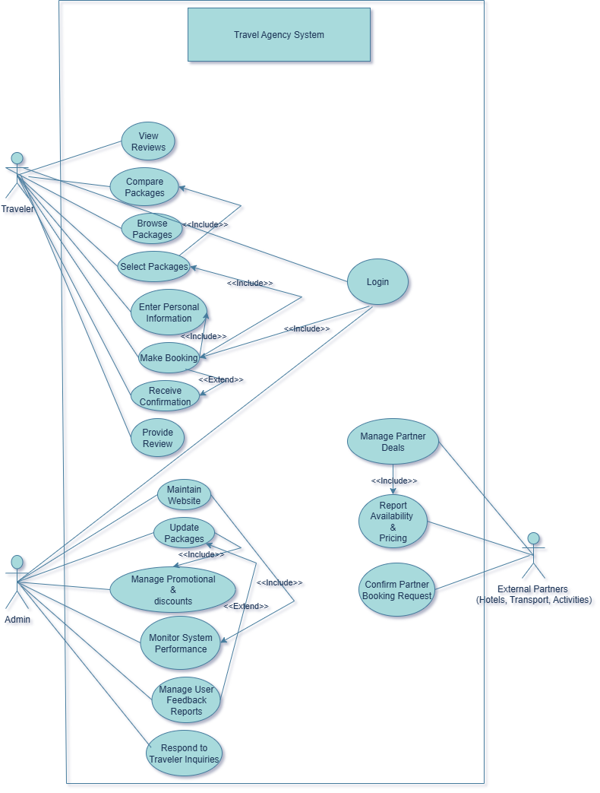
7.Activity Diagram
1) Activity Diagram: User Process:
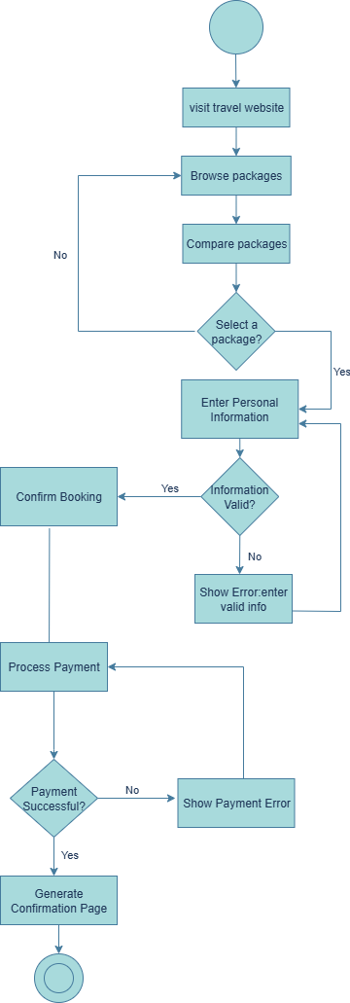

2) Activity Diagram : Browsing Partner Services

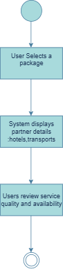
3)Activity Diagram:View Package Details

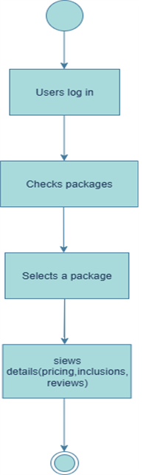
4)Activity Diagram:Browse travel Packages
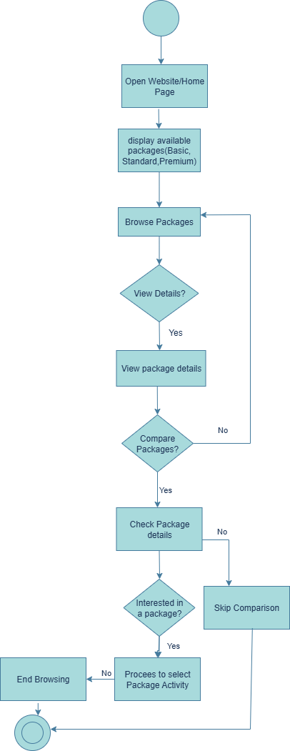

5) Activity Diagram: Select Package
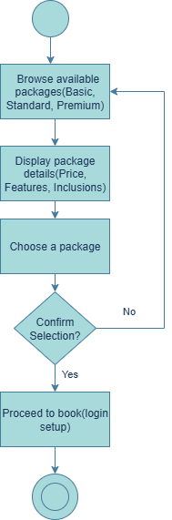

6) Activity Diagram: Booking confirmation:
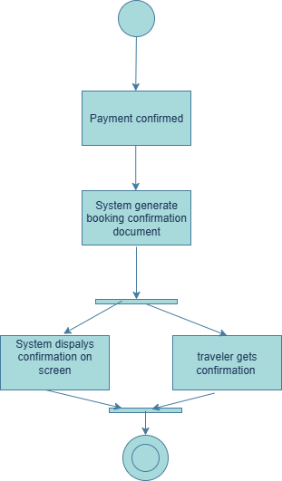
7) Activity Diagram: Payment Process

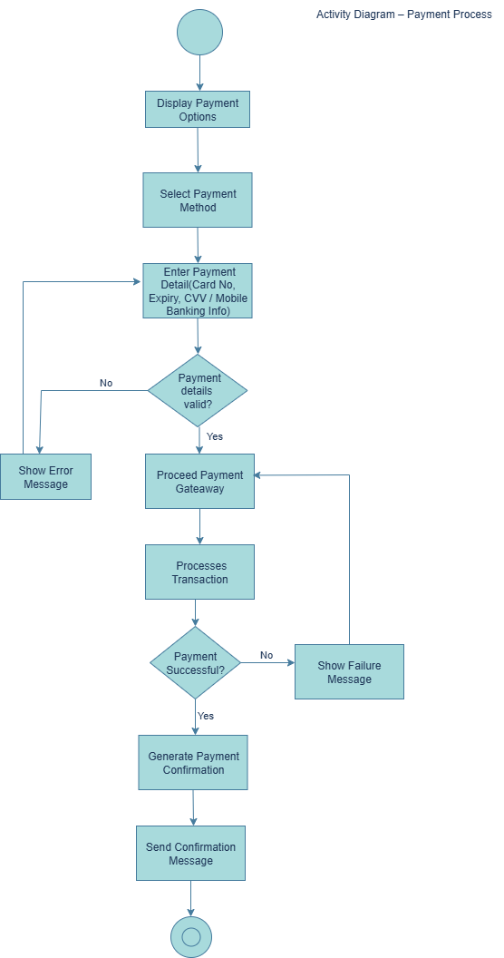

8)Data Flow Diagram
DFD Level: 0

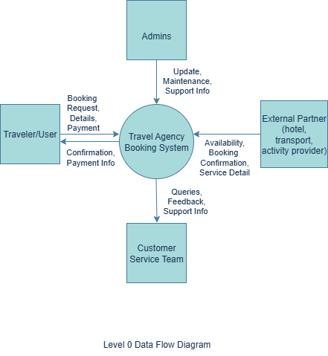

DFD Level :1

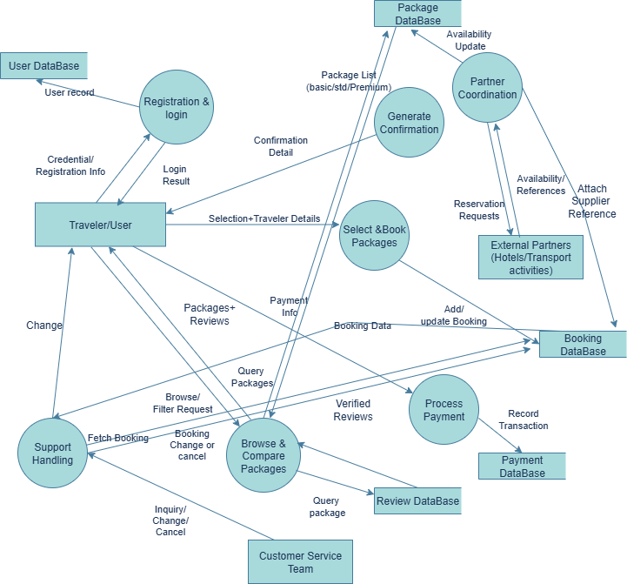

9)Component Diagram

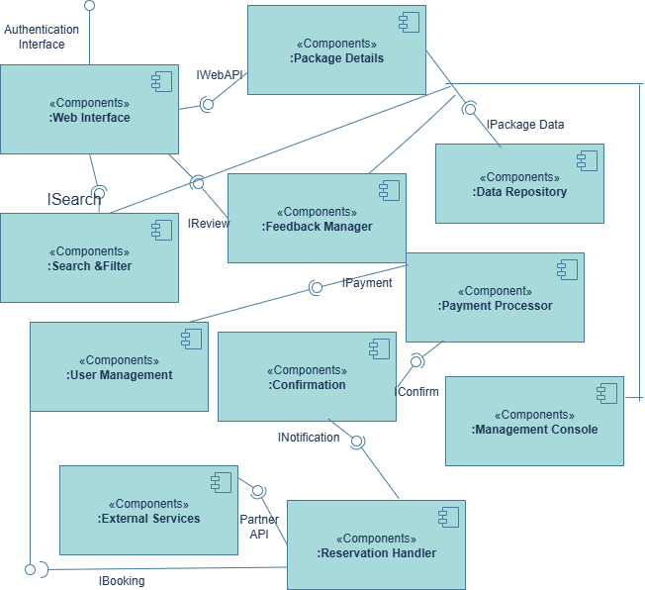

10) Class Diagram

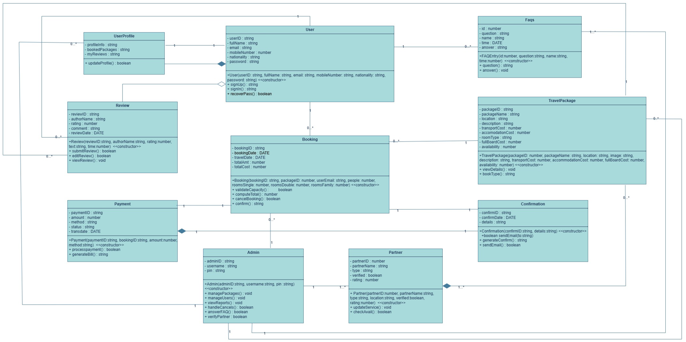

11) ER Diagram

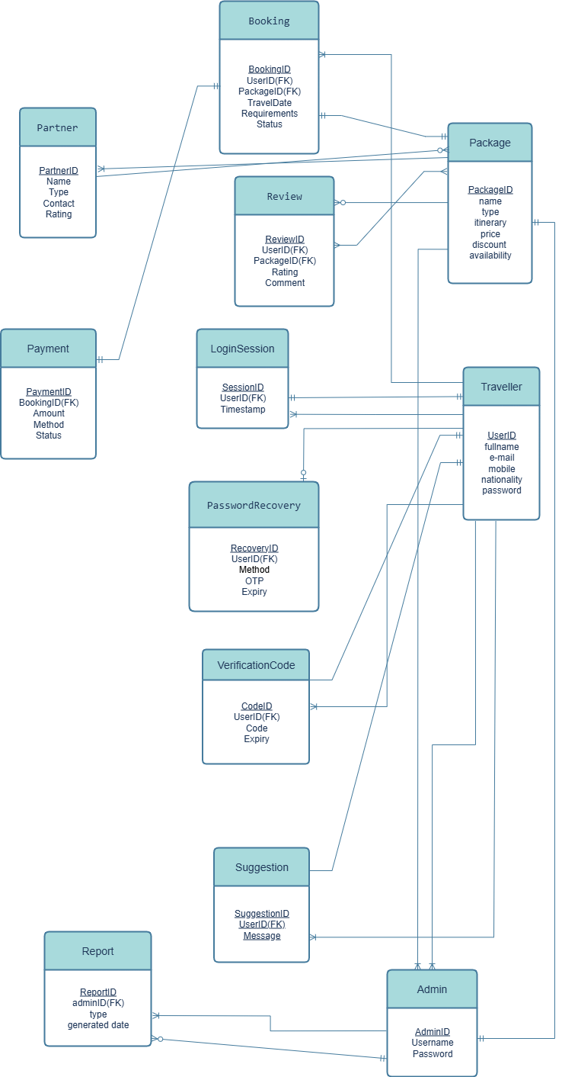

11)Sequence Diagram

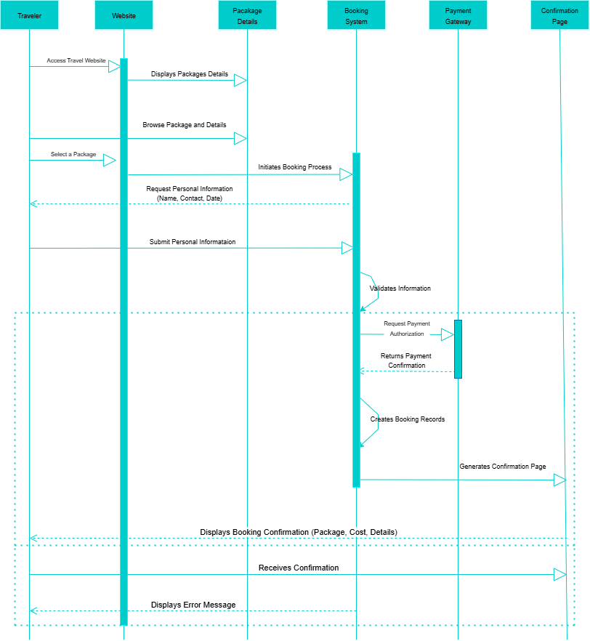

12) Project Snapshot
12.1 Home
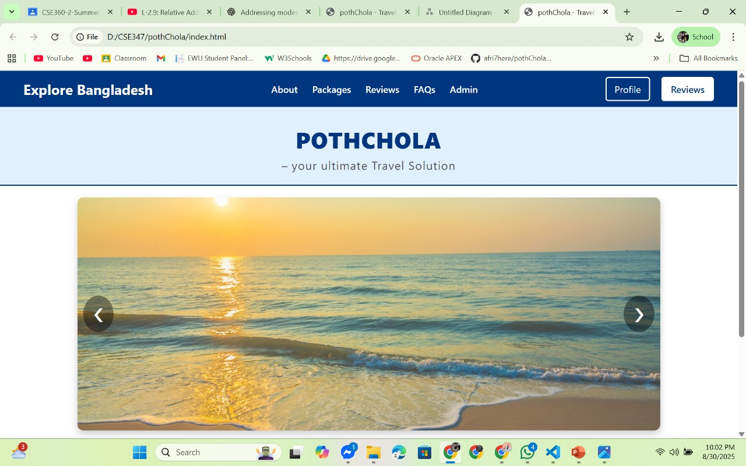

12.2 Admin profile

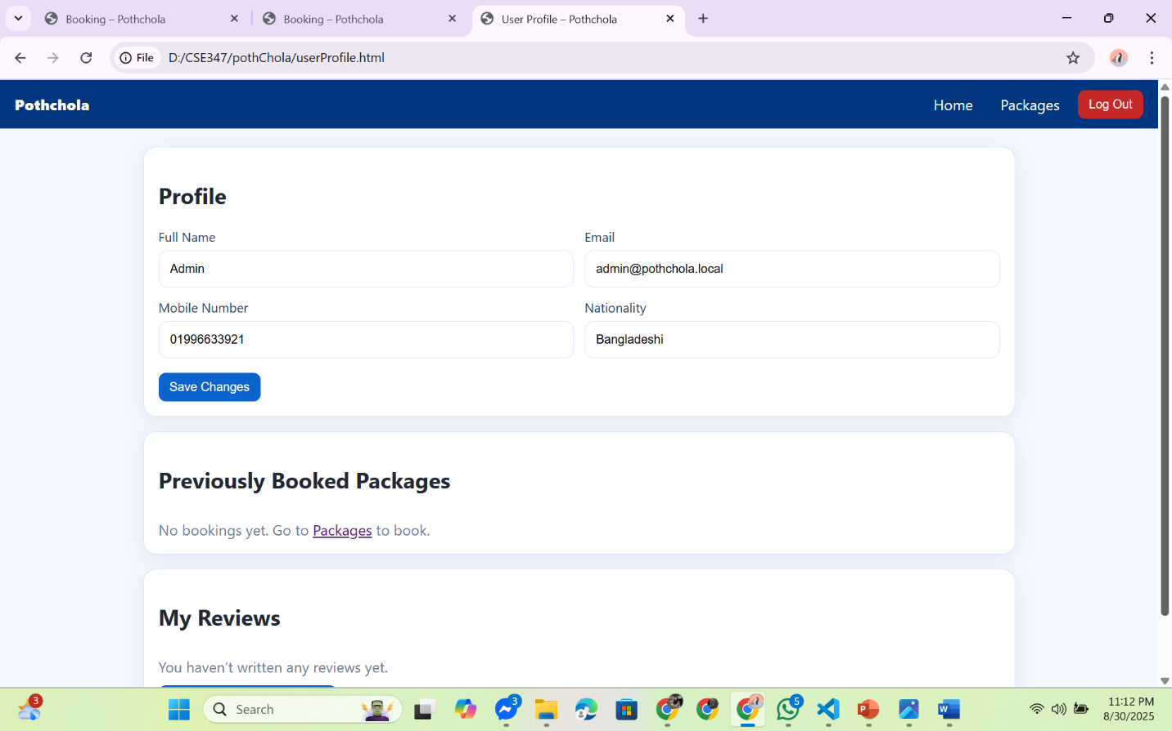

12.3 Travel Packages

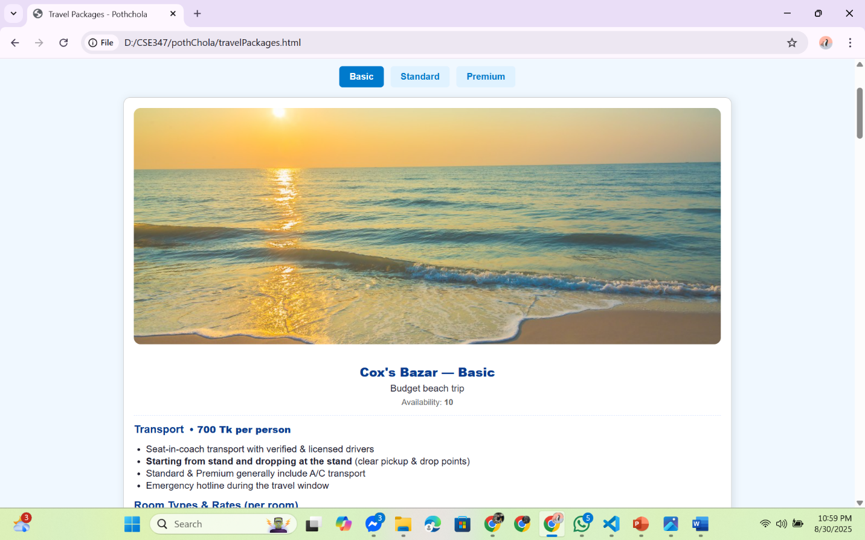

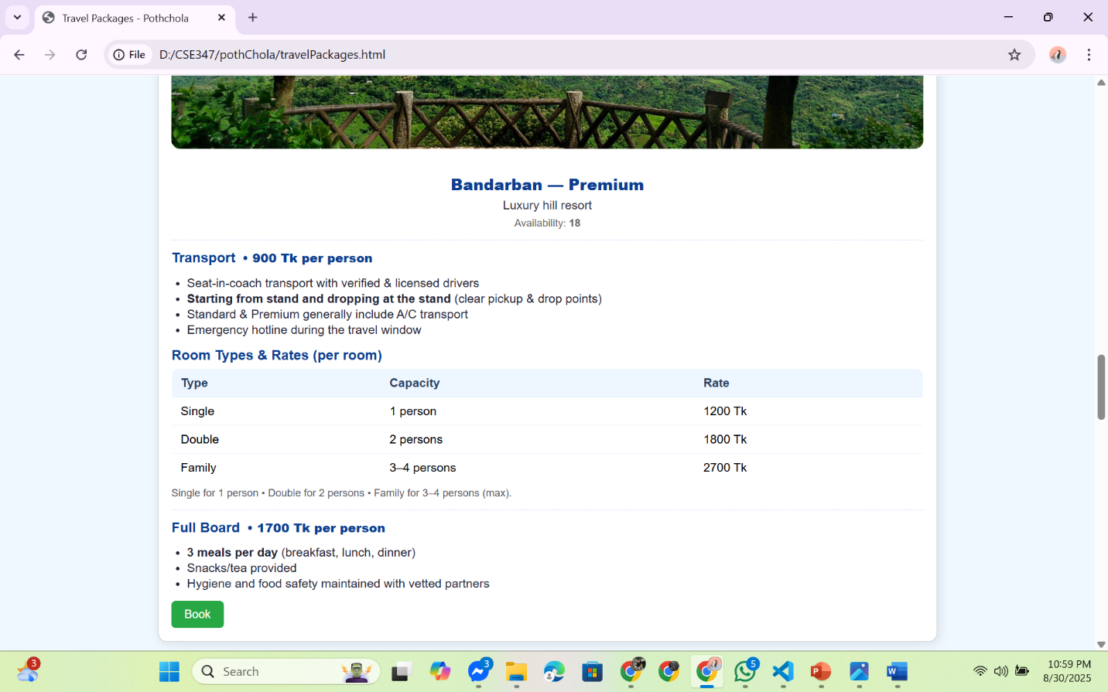

12.4 Booking Page
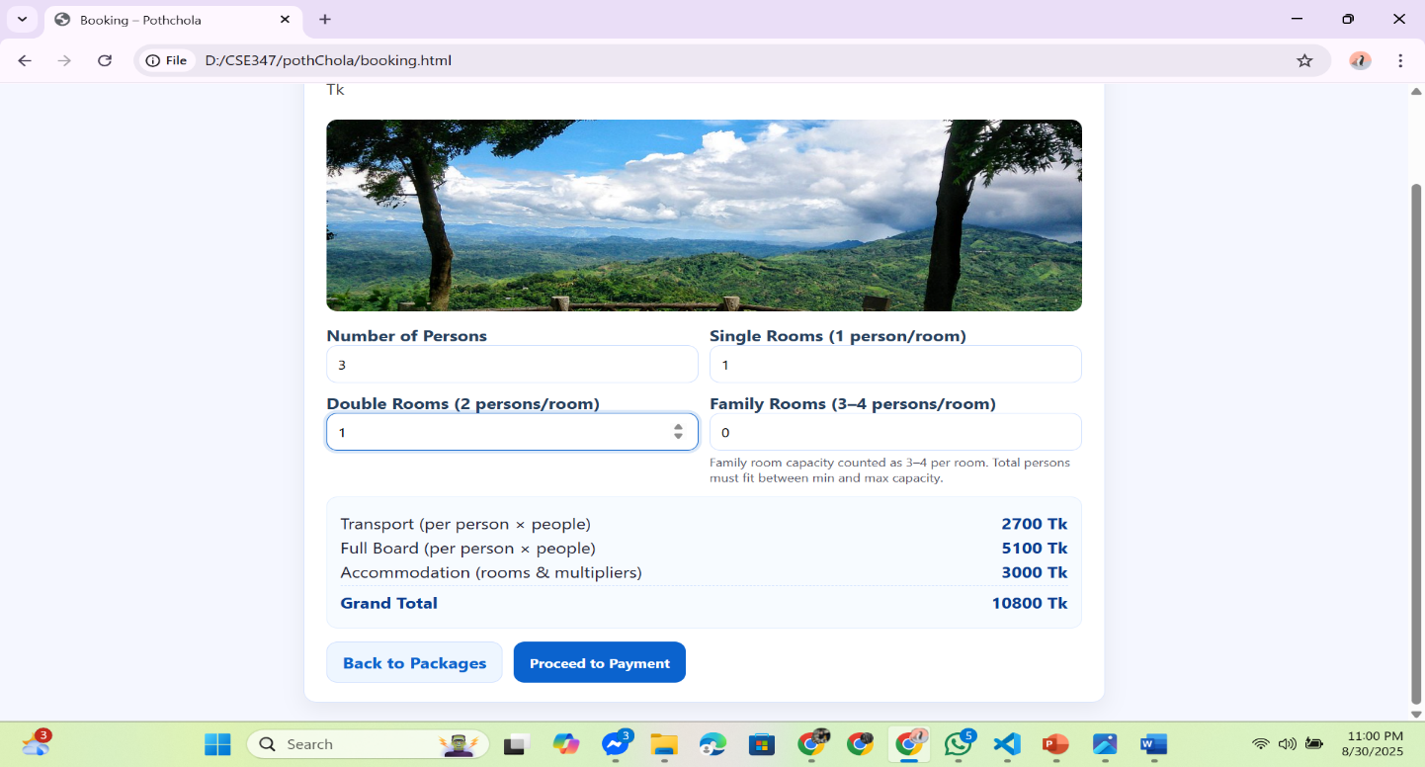

12.5 Payment Page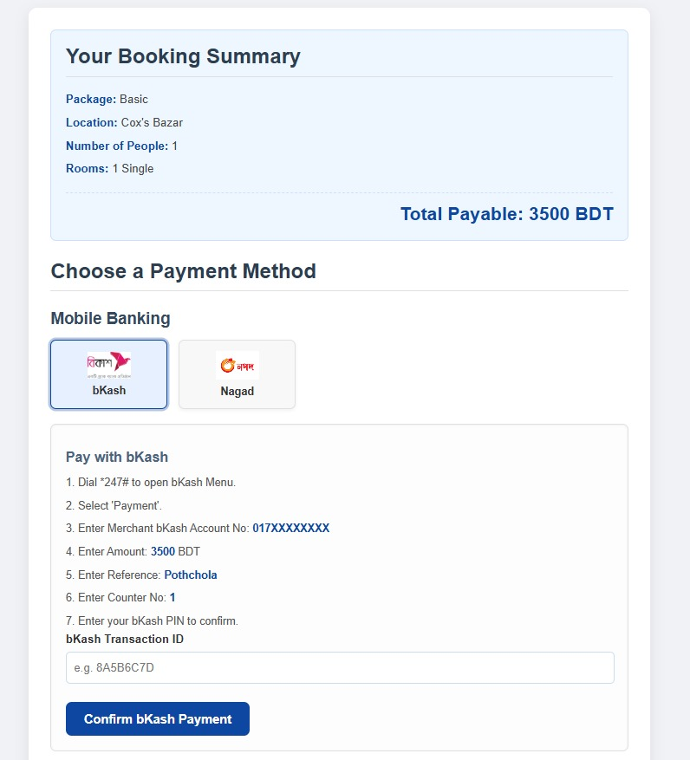
12.6 Confirmation
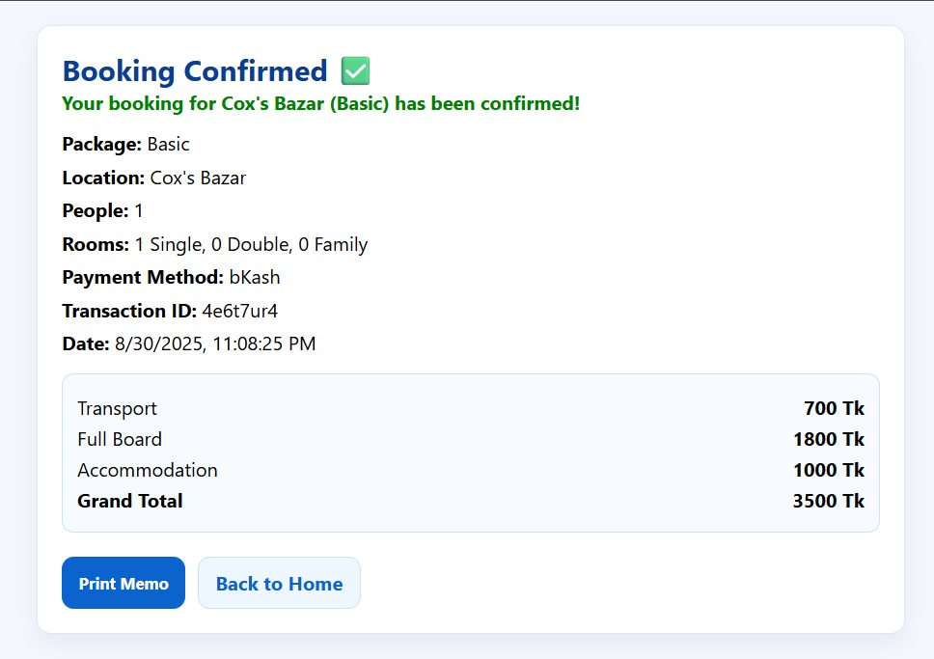

12.7 Reviews
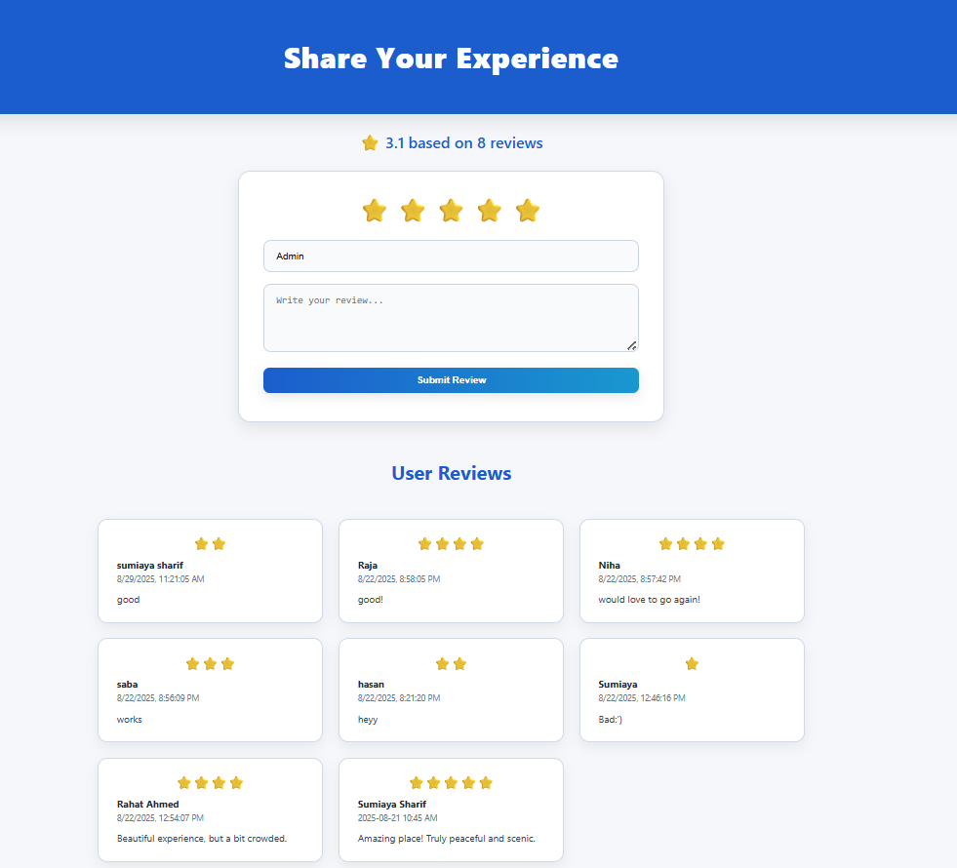

12.8 FAQs
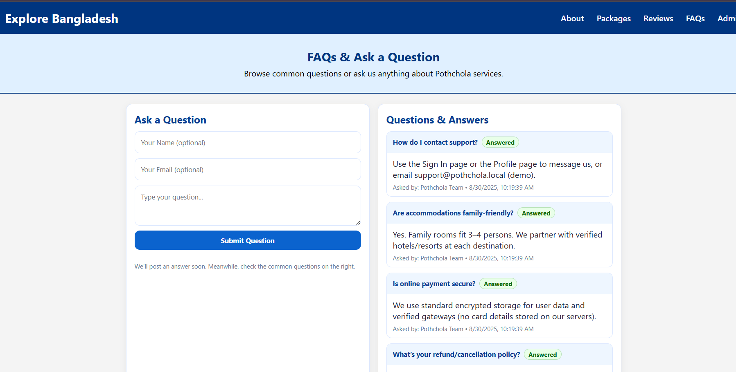

12.9 About
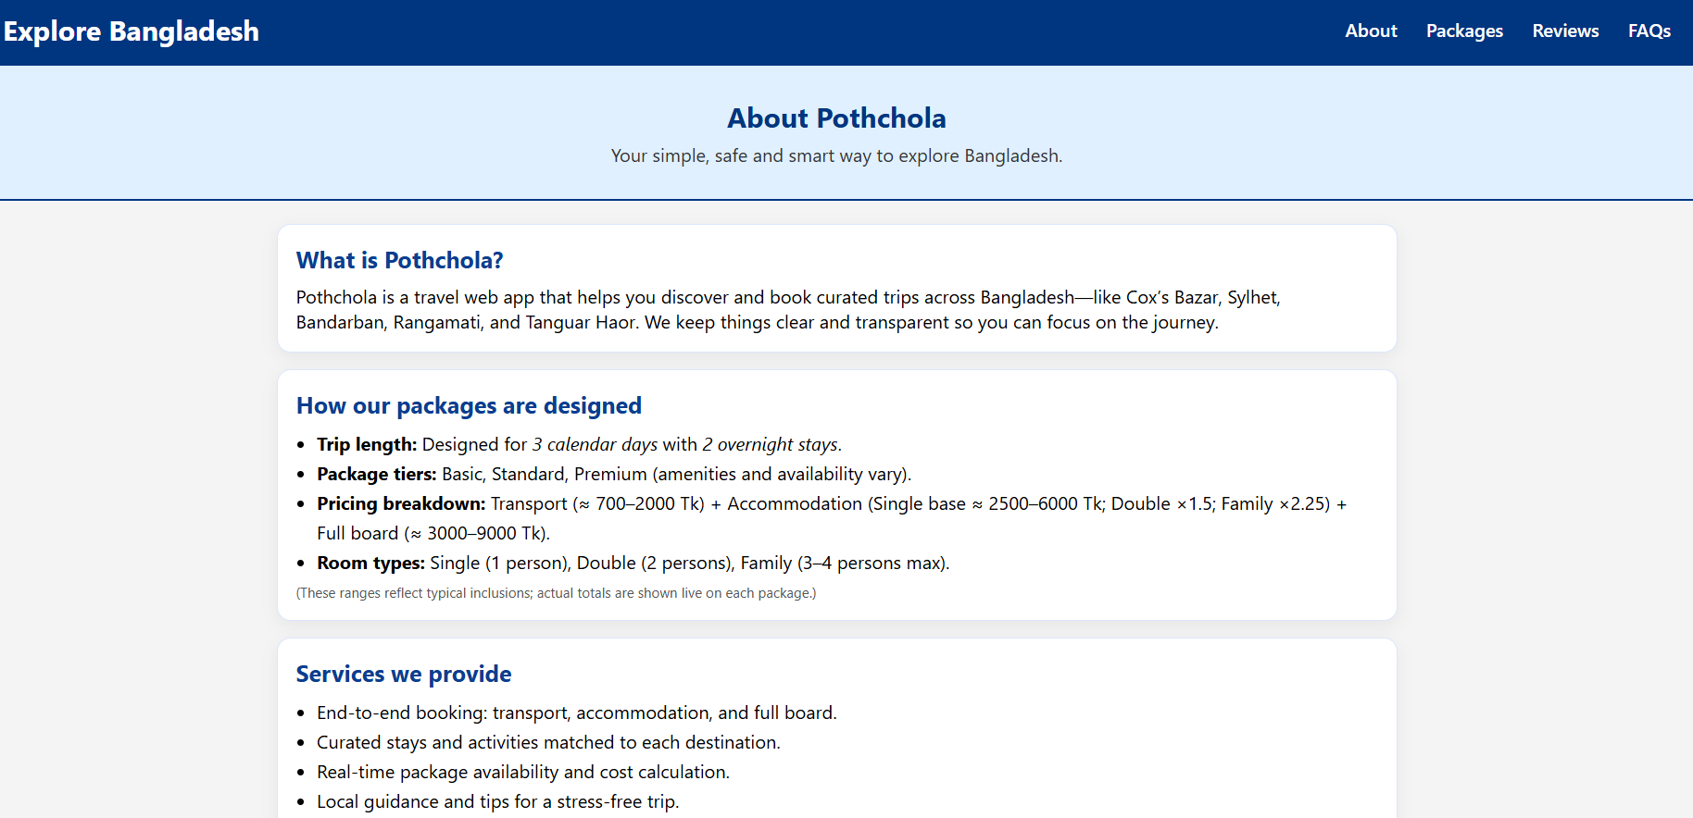

12.10 Admin Dashboard
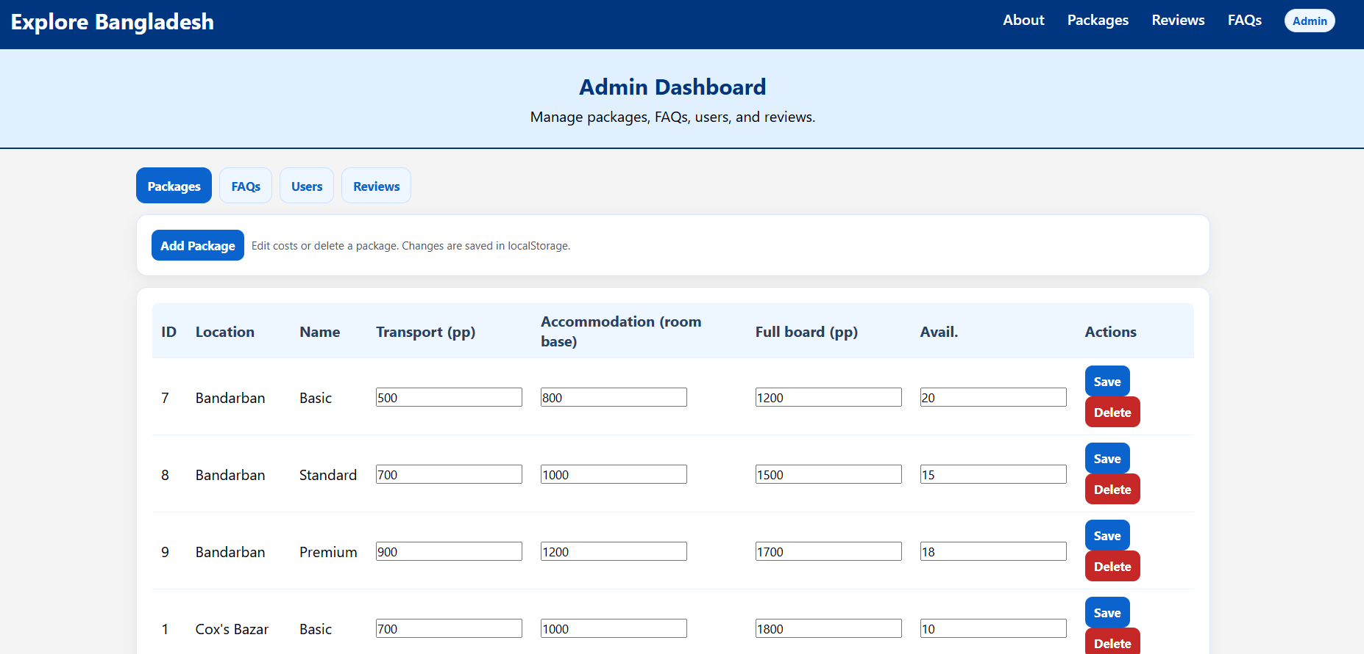

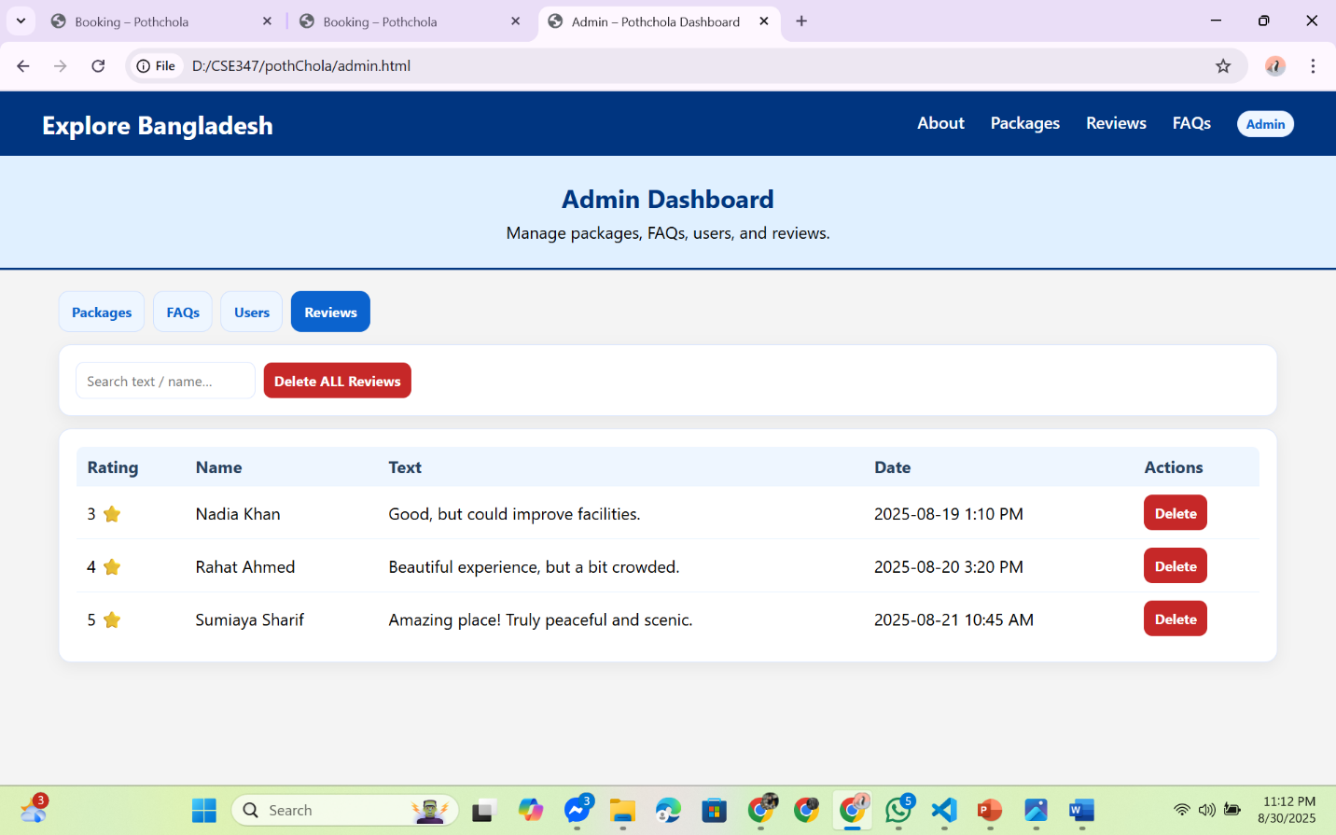
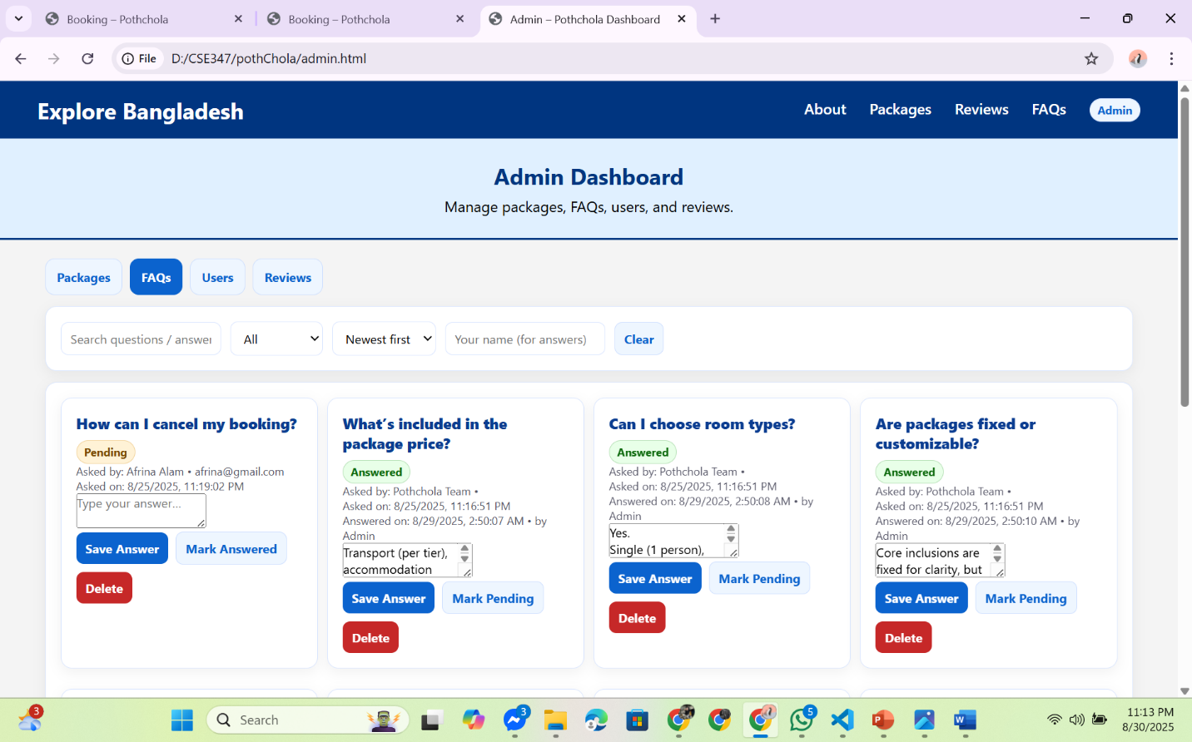

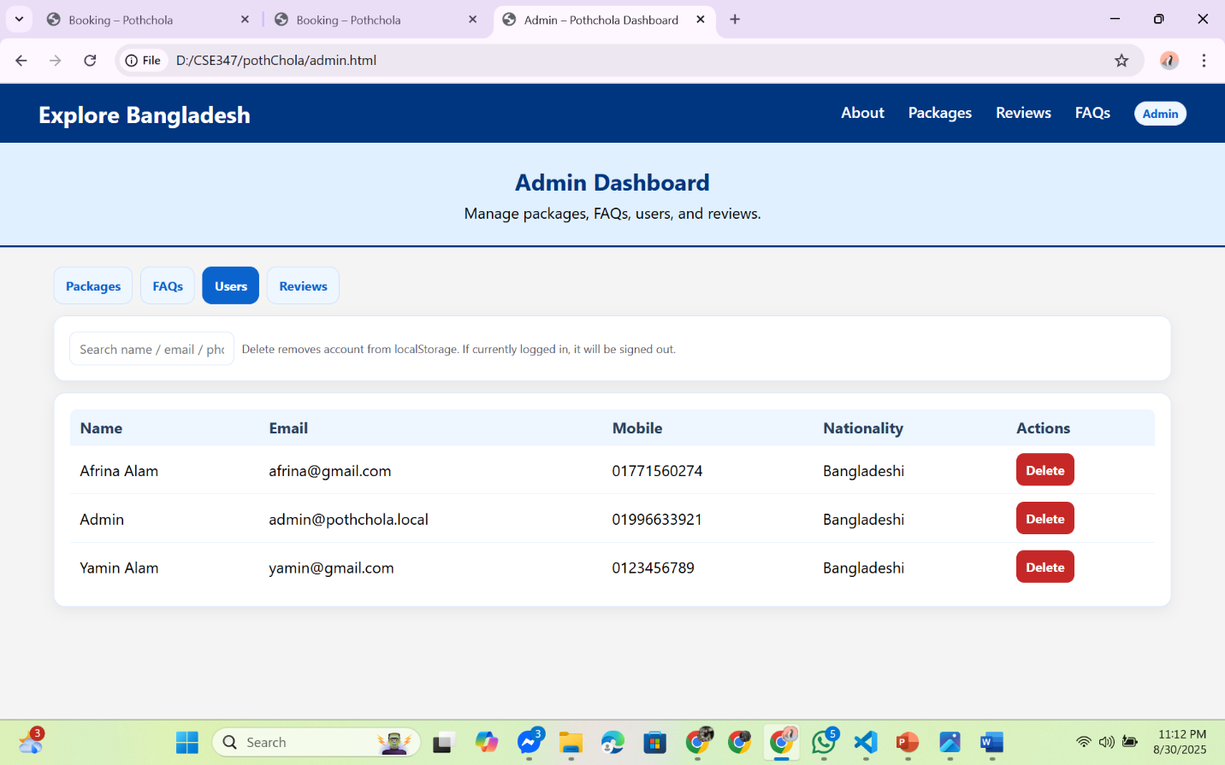

12.11 User profile
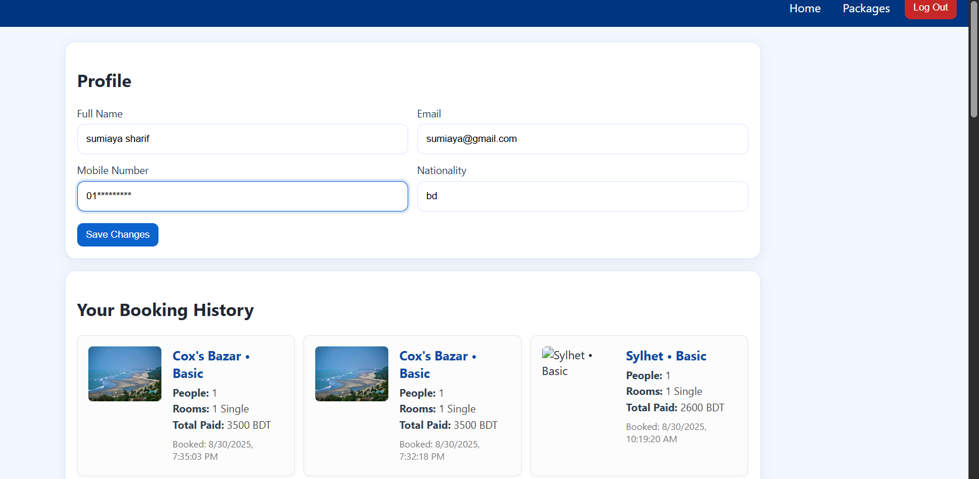
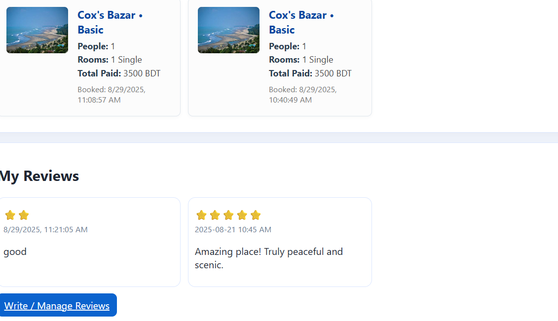

Limitations of our System:
The system currently relies only on localStorage for saving data such as users, bookings, and reviews, which means all information is lost if the browser cache is cleared, or if the user switches devices. Since there is no centralized database, data cannot be shared across multiple users, making the system unsuitable for real-world use. Additionally, authentication is insecure because the admin login is hardcoded, with passwords stored in plain text, exposing them to anyone who inspects the code.

In terms of scalability, the system functions as a demo but cannot support many users at once since there is no server to manage concurrency. For example, multiple travelers could accidentally book the same package without any conflict handling. Similarly, the payment system is only simulated, as it lacks real integrations with providers such as bKash, Nagad, or credit cards. Another major drawback is the absence of an email or notification system, meaning users do not get booking confirmations, and admins are not alerted about new bookings or reviews.

The platform also lacks role management, offering only one admin account with no way to create multiple admins, managers, or staff roles. Reviews are stored locally, so they are not shared across users, and there is no moderation to prevent spam or abuse. Moreover, data integrity is weak since tech-savvy users can directly edit values in localStorage.

From a user experience perspective, the system has limited features: there is no multilingual support for international tourists, no advanced search or filtering for packages, no interactive map for destinations, and no proper handling of complex group bookings. Additionally, there is no customer support or chatbot to help travelers. Finally, the range of packages is limited, which reduces flexibility for different types of travelers.
Conclusion:
The travel booking system successfully demonstrates the core functionalities of an online travel platform, such as user sign-up, login, package selection, booking, payment summary generation, and the ability for travelers to submit and manage reviews. An admin role is also included for basic management. However, the current system remains a prototype with several limitations. Since all data is stored in localStorage, it lacks persistence, scalability, and multi-user support. Security is minimal, with hardcoded credentials and no encryption. Payment integration, email/notification systems, and role-based management are missing, while user experience features such as package variety, search/filter, and multi-language support are limited.
Despite these drawbacks, the system provides a strong foundation for a travel booking website. By integrating a real database, secure authentication, online payment gateways, and enhanced user experience features, the system can evolve into a fully functional, scalable, and secure travel platform suitable for real-world deployment.

Github Link: http://github.com/Sumiaya256/Poth-Chola-A-Travel-Agency

